A Synopsis Report on

“Anti-Theft Tracking and Location Detection ”
(ATTLD)

Submitted in partial fulfillment of the requirement for
Degree in Bachelor of Engineering (Computer Engineering)

By

Chinmay Lad
Aditya Landge
Rohan Manudhane

Guided by

Mrs. Rakhi Kalantri



Department of Computer Engineering
Fr. Conceicao Rodrigues Institute of Technology
Sector 9A, Vashi, Navi Mumbai – 400703

University of Mumbai
2015-2016

CERTIFICATE

This is to certify that the project entitled

Anti-Theft Tracking and Location Detection
(ATTLD)

Submitted By

Chinmay Lad
Aditya Landge
Rohan Manudhane

In partial fulfillment of degree of B.E.(VII-Sem) in Computer Engineering for term work of the project is approved.

External Examiner Internal Examiner

_________________ ________________

External Guide Internal Guide

_________________ _________________

Head of the Department Principal

__________________ _________________

Date: - College Seal

i
ACKNOWLEDGEMENT

Firstly, we would like to thank our Principal, Dr. S. M. Khot, for giving us the opportunity and permissions to undertake this project.

We would like to thank Prof. H. K. Kaura, Head of Computer Engineering Department, for lending his full co-operation, despite his busy schedule, for the successful deployment of this project.

We are also indebted to Ms. M. Kiruthika, Coordinator of Computer Engineering Department, for her endless inspiration and support.

We take immense pleasure to thank our project guide Ms. Rakhi Kalantri for her constant supervision as well as for providing necessary information regarding our project. We would like to take this opportunity to thank her for her guidance and support throughout.

We would also like to thank Ms. Sandhya Patil and Ms. Shweta Tripathi, Project Coordinators, for their guidance and constant supervision throughout.

We would also like to thank all the other staff and non-staff members of Computer Department for their help.

ii
ABSTRACT

In today’s world of revolutionary innovative technology various gadgets that can ﬁt our pockets for everyday use are manufactured and made available at low rates. With the technology becoming cheaper, more people use different devices on a much larger scale with an exponential increase in the rate of sales. These days it’s very common for a person to own mobile phones, cars and other valuable tech items. However, these gadgets and items like mobile, purses, wallets, bags, etc. become easy target for thieves to steal them. With the increase in the robbery and such crimes it is very important to contain it. Gone are the traditional days of searching stolen items, with the techno-boom there is also increased intelligence available in the ﬁeld of security which should be harnessed. Hence, using this motivation to try and contain these robberies and actually recover the stolen item we introduce the idea of ATTLD (Anti-Theft Tracking and Location Detection Chip).

iii
INDEX

Sr. No. | Topic | Page No.
1. | Introduction | 1
2. | Literature Survey | 2
3. | Proposed System | 5
4. | Design | 8
5. | Hardware and Software Requirements | 16
6. | Feasibility | 18
7. | Timeline chart for VIII Sem | 22
8 | Conclusion | 23
 | References | 24

- INTRODUCTION

ATTLD is a Bluetooth tracking device that when installed or mounted on an object can be used for tracking and providing the object’s location and give the information to the owner (via website). There are many cases where the object gets misplaced or stolen or lost. These misplaced object can be found if a tracking device is attached to it. This device can then give the location of the object. The ATTLD Chip is an attempt to make a tracker cum locater device which using Bluetooth performs both the functionality and helps retrieve the lost/misplaced object.
The main aim of the project is to provide the above mentioned functionality that can be commercialized for actual use for tracking and locating.
This project provides:
- Device tracking in vicinity of the object using Smartphone App.
- Locating the lost item by tagging it lost on the server.
- Easy and efficient way for searching objects without consuming any time and energy.

As suggested above the ATTLD functions into two scenarios for tracking of the lost objects. The additional feature ATTLD has is that it can communicate with other ATTLDs in its proximity and make the owner of the device aware of the location. All the owner has to do is to go to the site and ﬂag his device as stolen so that other ATTLDs are aware of the stolen device. This makes the location of object a relatively simpler task. If the device with the chip on it gets stolen then the location I.D is sent to the company which then sends alert messages to all the other devices in the vicinity. All the other chips of the vicinity will start searching the particular chip with the I.D and as soon as any chip ﬁnds the chip in question then the location is found of the stolen device which can then be retrieved. The task of this project is to develop a means of communication by which the stolen object can be tracked.

1
2. LITERATURE SURVEY

2.1 Bike Tracking - Tracking Stolen Bikes through Everyday Mobile Phones and Participatory Sensing :

Authors: Ted Tsung-Te Lai, Chun-Yi Lin, Ya-Yunn Su, and Hao-Hua Chu.
Bicycle theft has been a well-known issue for many years. This study presents BikeTrack[6], a participatory sensing system that uses everyday smartphones and low-cost Bluetooth devices to help people recover their bicycles. In BikeTrack[6], a customized Bluetooth tag mounted on a participant’s bicycle broadcasts a beacon ID for bicycle identification. To detect the presence and location of a bicycle, BikeTrack[6] participants use Bluetooth and GPS enabled smartphones to upload data to a remote server. Users can also check their bicycle’s last seen location. To evaluate the feasibility of BikeTrack[6], a two week user study with eleven participants was conducted at a school campus. Preliminary user-study results show that the bicycle and its location was detected 5.1 times per day on average and mostly locate within campus boundary. The paper mentions that the user smartphones detect other bikes at different times of the day, suggesting that potential battery reduction can be applied based on user behavior.

2.2 Anti-Car Theft System using Android Phone:

Authors: Jake M. Laguador, Moulle M. Chung, Frina Joy D. Dagon, Julie Ann M. Guevarra, Rommel J. Pureza, Jeffrey D. Sanchez, and Dan Kenneth I. Sta. Iglesia.
The Rapid growth of technology and infrastructure has made our lives easier. The whole system allows the user's mobility to be tracked using a mobile phone which is equipped with an internal GPS receiver and a GPRS transmitter. A mobile phone application has been developed and deployed on an Android Phone whose responsibility is to track the GPS location and send it to a remote location. Currently almost of the public having an own vehicle, theft is happening on parking and sometimes driving insecurity places. The safe of vehicles is extremely essential for public vehicles. Vehicle tracking and locking system installed in the vehicle, to track the place. In this system client just send one message to the vehicle and the vehicle mobile will send you the current location of your vehicle in the form of web link and user has to click on a link and that link goes to google map and will show the current location of your vehicle.

2

2.3 Bluetooth an Optimal Solution for Personal Asset Tracking:

Authors: Saleem Ahmad, Ruoyu Lu and Muhammad Ziaullah.
This paper aims to present a comprehensive study for various Asset Tracking technologies. This study scales down from introduction of chief underlying tracking and localization principles to technologies and systems at higher level. At lower tier, they introduce schemes like triangulation, Time difference of Arrival (TDOA or trilateration), multilateration, Angle of Arrival (AOA), Doppler, Signal Strength (RSSI), Beam forming etc. At surface tier, the primary focus has been laid on RFID and Bluetooth based technologies while an overview of other technologies like satellites (GPS), cellular (GSM) or data connectivity (WIFI) etc. An insight to associated schemes like Active and Passive, Indoor and Outdoor, and Behavioral Sensing augment this. Each technology is further analyzed with benefits and drawbacks for a tracking solution. After technical insight, they will focus our study on Personal Asset tracking and highlight the pros and cons of previously mentioned tracking technologies in line with five aspects; Accuracy, Budget, Energy, Host and Platform independence. Within these five regimes, they tabulate the requirements of an affordable, efficient and practicable scheme and illustrate with current examples. They keep their focus on a common user who has a cell phone in-hand and resolve an optimal tracking solution within the resources available to him. As a consequence they conclude Bluetooth Low Energy based tracking schemes to be optimal candidate. This paper aims to serve as a compendium for the readers who wish to get an overview of such technologies without going into discrete technical details, and propose the Bluetooth based tracking scheme as a viable and affordable solution for a common user.

3
2.4 WiFi Tracker:

Path and location tracking are one of the main interesting and fast growing applications in mobile and wireless communications. The developments of such systems have interested many research, industrial and government bodies with solutions that range in scale and accuracy. The GPS system, cell based tracking in cellular networks are just few examples. However such technologies have their limitations. GPS does not work inside buildings, cellular systems are not owned by organizations and only work with mobile phones and have high subscription fees. The prototype implemented in this paper illustrates a simple path and location tracking system within an organization based on its available infrastructure Wi-Fi network. By using signal strength and histories of access points used by a mobile node we can provide an approximate determination of the location in the services area and also the moved path of the mobile node. In our work we use Web services for location services to enable queries and manage the path and location of the mobile node. The paper mentions that the system has shown impressive results that enable software developers to provide useful types of location based service applications for organizational tasks.

4
3. PROPOSED SYSTEM

ATTLD is an attachable tracking device that uses Bluetooth low energy to help track any item that you’ve paired with your smartphone.
Following are some of the functionalities of the Proposed System for ATTLD Device:
- User can make ATTLD buzz, sound or ﬂash LEDs by pressing the button in the Application from your Smartphone to detect the mobile device or gadget to which ATTLD is attached.
- By pressing the detection key in your ATTLD device provision will be made to detect the Smartphone to which the ATTLD device is synchronized with.
- ATTLD will sound, vibrate and ﬂash LEDs automatically when about 10 meters away from your Smartphone .i.e. it will indicate that the ATTLD device is moving out of the Bluetooth range of the Smartphone.
- If you mark an item as lost the entire ATTLD community of users will help you ﬁnd your ATTLD securely. This essentially expands your reach in ﬁnding your device. The more family and friends in the community, better the capability. ATTLDs can be designated to easily discover which of your friend ATTLDs is closest to your lost.

In general the overall functioning of the system is categorized into two distinct scenarios. One of which is to detect the ATTLD device with the vicinity of the the smartphone, while the other scenario is to detect the ATTLD device outside the vicinity of the user smartphone.

The stated scenarios are explained below as:
- Scenario 1
- Scenario 2

5
3.1 Scenario 1

In the ﬁrst scenario, gadget location on which the device is mounted is found out by the strength of the signal between the smartphone and the ATTLD chip. As the chip is in the vicinity it can be connected to the smartphone and based on the signal strength the user could be able to navigate to the gadget. This is done by receiving the RSSI[5][9] value. The RSSI value returns the signal strength between the devices. When the distance between the devices
increase the RSSI value drops down and accordingly the user is indicated that the signal
strength is decreased. Therefore when the user goes in one direction for searching the gadget he/she will see the signal strength, if the signal strength drops the the device is not in the direction they are going and thus can change the direction. Eventually the user reaches the gadget as the signal goes on strengthening.

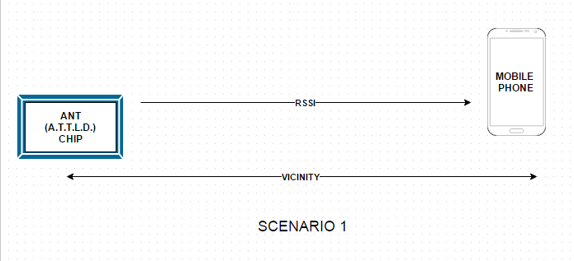

Figure 3.1: Scenario 1- Vicinity search

6
3.2 Scenario 2

In the second scenario, to ﬁnd out the gadget location is much complicated. The gadget in not in the vicinity and thus cannot be connected to the ATTLD Chip. If the user is not able to ﬁnd it, then he/she can go upto the web server and tag the device as stolen. Tagging the device as stolen put the device in the search list and this search list is updated in smartphones that have the ANT App. Thus when the stolen chip comes in contact with any of the smartphone the smartphone sends it location to the server and the corresponding owner of the chip is informed. This works in the following manner the list of devices which are tagged lost or stolen are updated to all the smartphones containing the ATTLD app. When the stolen chip is in the vicinity of the smartphone app, the smartphone immediately send its GPS[7] coordinates to the server. Based on the coordinates received server maps the location and the user is notiﬁed the user then can untag the device from the list or if the device is not found at the location the user may leave the tag on the device and let other smartphones ﬁnd the chip. The proposed work would be to analyse various parameters mentioned above by changing the existing setup.

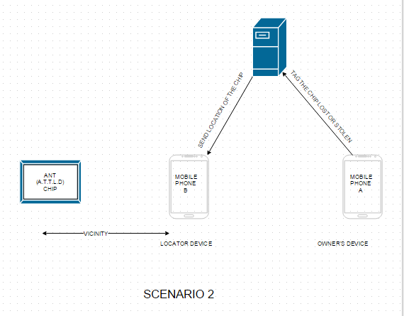

Figure 3.2: Scenario 2 - Ad hoc Search
7
4. SYSTEM DESIGN

Software design is the process by which an agent creates a specification of a software artifact, intended to accomplish goals, using a set of primitive components and subject to constraints. Software design may refer to either "all the activities involved in conceptualizing, framing, implementing, commissioning, and ultimately modifying complex systems" or "the activity following requirements specification and before programming, as a stylized software engineering process."

For this project, there are diagrams which show how the implementation of the system can be done. They are:
- Workflow Diagrams.
  - Workflow Diagram 1 (Vicinity Search and Lost Device Tagging)
  - Workflow Diagram 2 (Ad hoc search and User Notification)
- Use Case Diagrams.
- State Chart Diagrams
- Activity Diagrams.

These diagrams show the overview of functioning of the system by providing knowledge about interfacing, interaction and the processing taking place in the system whenever a device is lost. The diagrams can also be seen as visual representation making it easier for stakeholders to understand the business problem and accordingly helping them to their part more efficiently.

8
4.1 Work Flow Diagrams

4.1.1 Workflow Diagram 1

Figure 4.1 represents the workflow of the Search functionality that is performed while searching the “misplaced” device/object. The Workflow in the above figure shows that initially when the user wants to search for the object he/she goes to the ATTLD smartphone app and then goes in search function. In this function the app first checks whether the ATTLD chip is already connected or not. Based on the outcome the app decides to do one of the two things.
- Start the search operation.
- Detect the device and connect to it.
If the device is not already connected then the app detects the device and connects it. Once the connection is established it is implicit that the object is misplaced and not lost i.e the object is in the vicinity. After establishing the connection the user then check the strength of the Bluetooth signal. The user then navigates across the area making sure that he only goes in the direction in which signal strength increases. Once the signal strength is maximum the user then can locate the object in that spot. However it is sometimes the case that the object is hidden in some corner due to which it is invisible to user even when the app shows the maximum signal strength. For this purpose, the CHIP can be made to buzz and beep so the user can then exactly locate the hidden device thus finding it. This is the case when the device is misplaced in the vicinity. Suppose if the device is lost and is not present in the vicinity. When the user uses the app the CHIP shows not connected. Then the user tries and detect the chip, yet the chip is not detected. This in turn suggests that the chip is not in the vicinity and is lost. The user then can choose to tag the device as lost and proceed to the app for the same.
Once the chip is tagged as lost, the app notifies the server regarding the lost chip. The server then updates the lost devices list and notifies other apps regarding the updated list.
Figure 4.1 workflow diagram only show one scenario workflow and also the flow when the user realizes the device is lost.

9
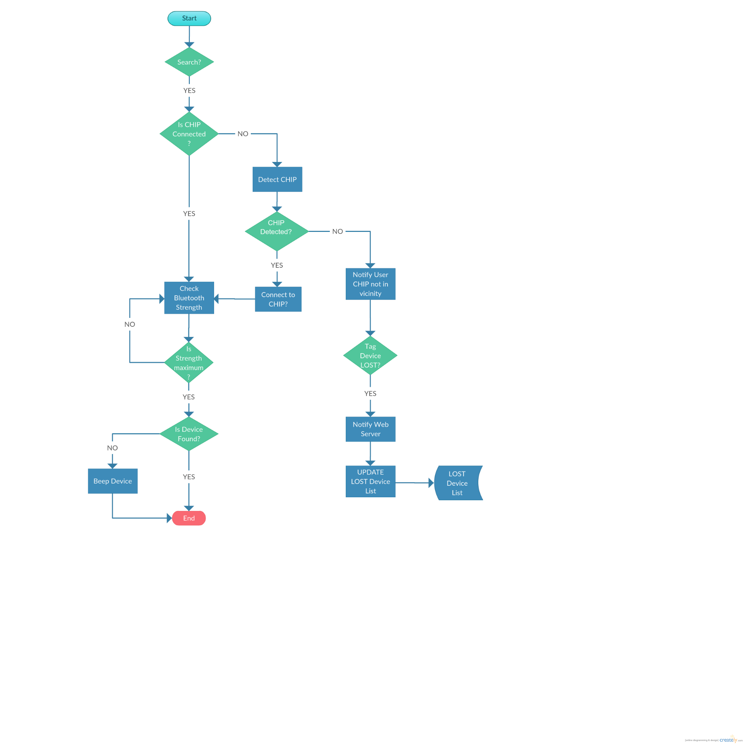

Figure 4.1: Workflow Diagram 1

10
4.1.2 Workflow Diagram 2

Figure 4.2 represents the workflow diagram similar to Figure 4.. However the search functionality being used here completely different from the one that was being used earlier.
In Workflow diagram 1 we had used vicinity search, wherein the smartphone is used for searching the misplaced device. In Figure 4.2 workflow diagram the search functionality is implemented by other CHIPs that are used a surveillance chips for detecting any lost device. Once the device has been tag lost, immediate updates are made in the LOST device list. When another user opens the app, the first thing that happens is that the app synchronizes with the LOST device list from the server. The app then forwards the updated list to the “surveillance chip” which then is in constant search mode for detecting the lost devices. If any device is detected the chip first checks if the ID of detected CHIP is in the lost device list or not. If not the chip ignores the device. Else the chip notifies the smartphone app which in turn notifies the server giving the details of the location. The server then notifies the user regarding the whereabouts of the lost chip he had tagged.
Here we have stored the list of lost devices both in the smartphone and in the chip as both can be used for surveillance.

11

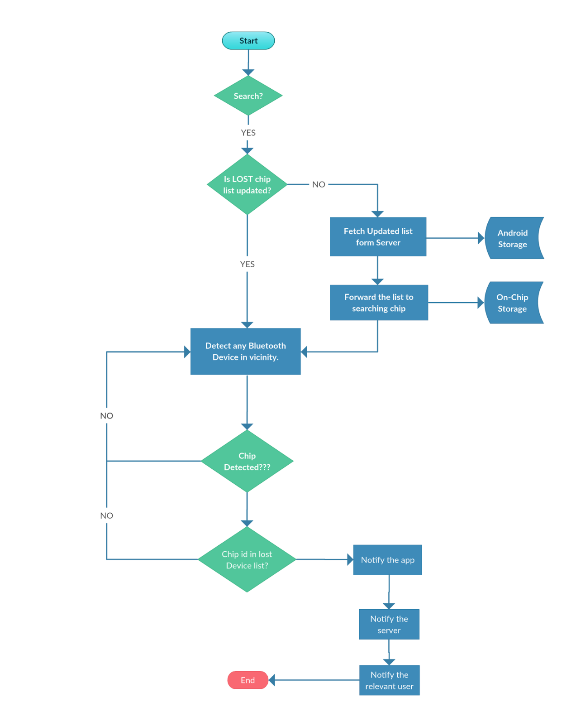

Figure 4.2: Workflow Diagram 2

12
4.1 Use Case Diagram:

The USE CASE Diagram is used for understanding the roles and interactions that take place between the SYSTEM and its Stakeholders of the system and help to properly understand the role of each stakeholder in functioning of the system.
This use case diagram suggest that the ATTLD system interacts only with the end user of the system who uses functionalities like connecting to chip, Tag device as stolen or make a vicinity search. Rest functionalities are performed by the system and do not require user interactions.

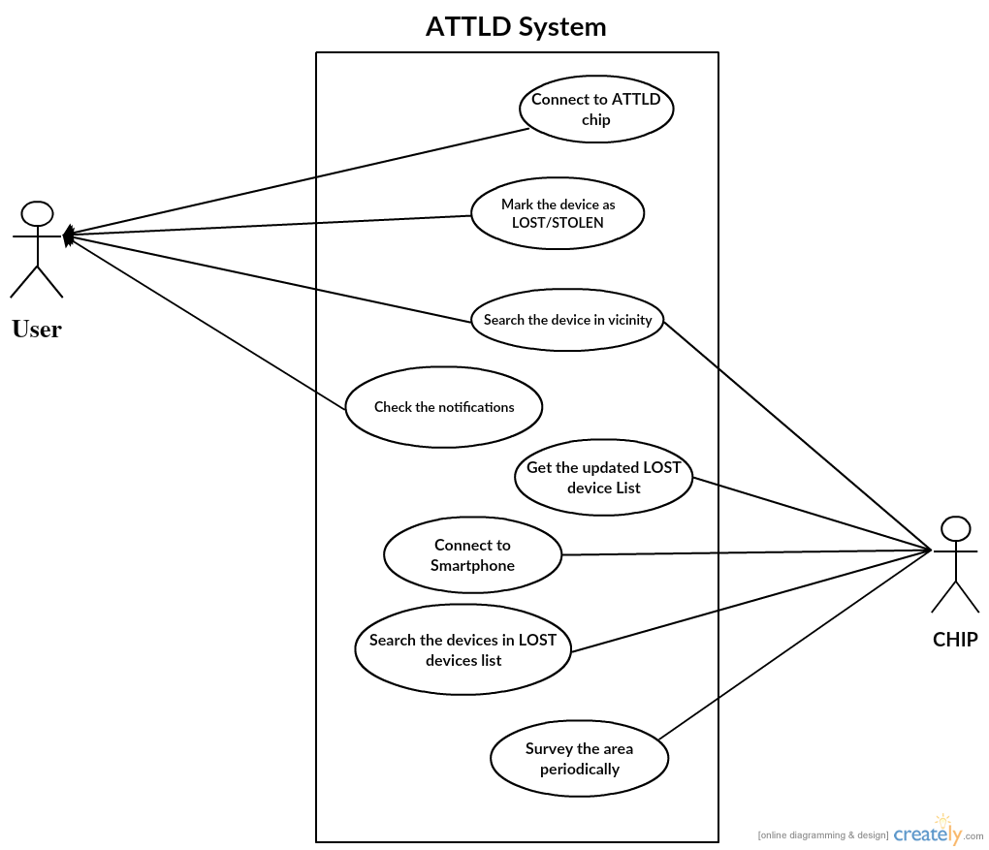

Figure. 4.3: Use Case Diagram for ATTLD

13
4.2 State Chart Diagram

Statechart diagram is one of the five UML diagrams used to model dynamic nature of a system. They define different states of an object during its lifetime. And these states are changed by events. So Statechart diagrams are useful to model reactive systems. Reactive systems can be defined as a system that responds to external or internal events.
The given state chart diagram shows the states the system goes through when a Vicinity search is made for the device.

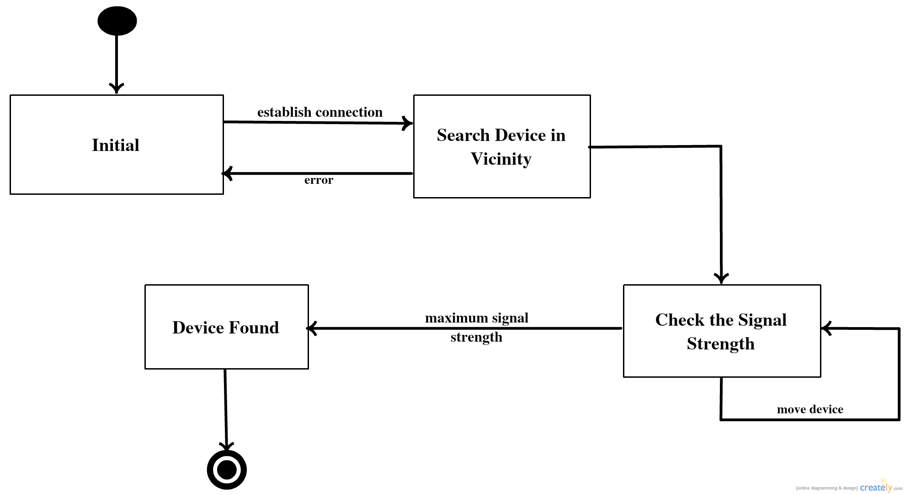

Figure 4.4: State Chart Diagram ATTLD System

4.3 Activity Diagram

Activity diagram is basically a flowchart to represent the flow from one activity to another activity. The activity can be described as an operation of the system.
14
So the control flow is drawn from one operation to another. This flow can be sequential, branched or concurrent. Activity diagrams deals with all type of flow control by using different elements like fork, join etc.

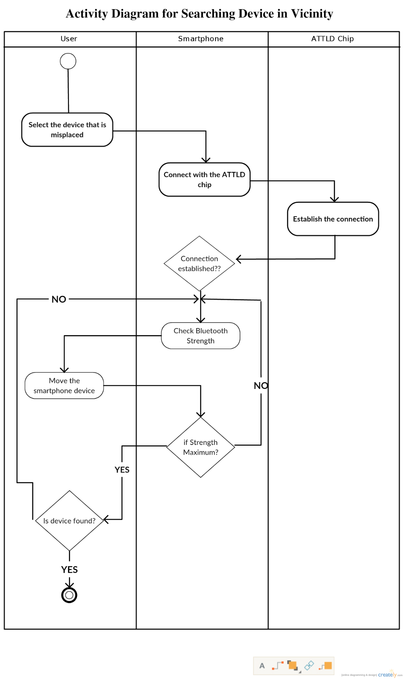
Figure: 4.5: Activity Diagram
15
5. HARDWARE & SOFTWARE SPECIFICATIONS

5.1 Hardware Specification
- Bluetooth Module
- Arduino Board

5.2 Software Specification
- Android
  - Android SDKs
  - Android Studio (Android Development IDE).
- Arduino Software
  - Arduino Libraries.
  - Arduino Drivers.
  - Arduino IDE 1.6.5.

16
Component Description

FLORA- Wearable platform:
Adafruit's fully-featured wearable electronics platform. It's a round, sewable, Arduino-compatible microcontroller designed to empower amazing wearables projects.
We are using this hardware to interface it with the bluetooth module for making and establishing connection between different chips and smartphones. Its is also used for processing the lost device list and checking if the connected chip belongs to it or not.

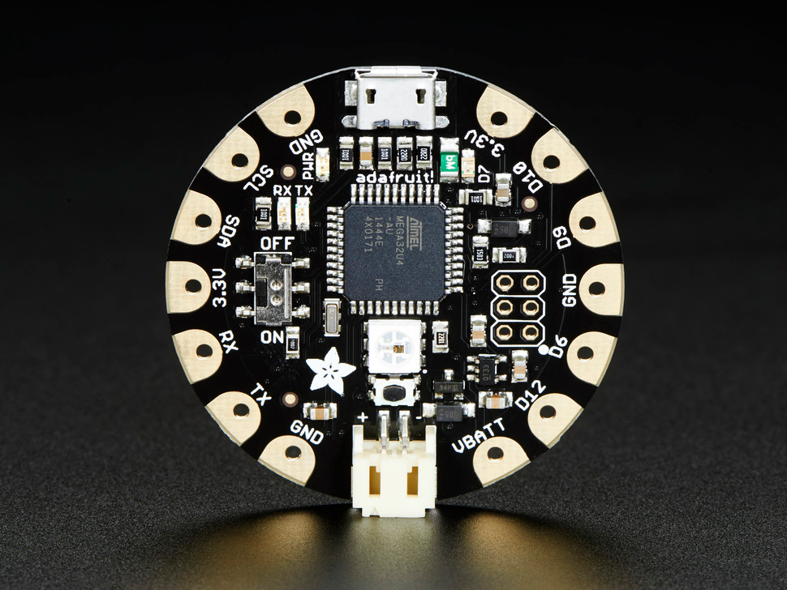
Figure 5.1: FLORA Wearable platform Arduino compatible.

2. Flora - Wearable Bluefruit
The Flora Bluefruit LE makes it easy to add Bluetooth Low Energy connectivity to your Flora. It can be easily attached to the any arduino platform for making small and easy projects.
In this project this hardware is used for enabling Bluetooth functionality by interfacing to the wearable platform and then.
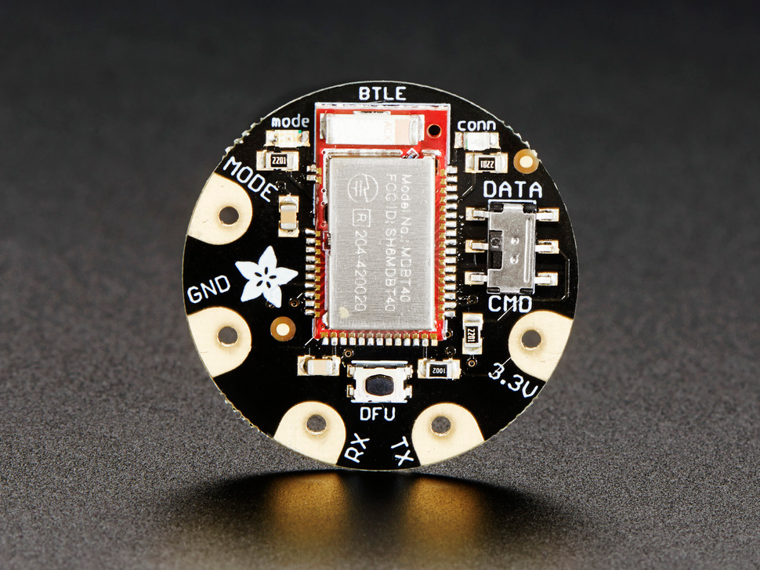
Figure 5.2: FLORA - Bluefruit Adafruit

17
6. FEASIBILITY STUDY

6.1 Technical Feasibility:
The technical feasibility assessment is focused on gaining an understanding of the present technical resources of the organization and their applicability to the expected needs of the proposed system. It is an evaluation of the hardware and software and how it meets the need of the proposed system.

For the completion of the ATTLD chip we would need the following components:

1] Bluefruit LE - Bluetooth Low Energy (BLE 4.0) Breakout:

The Adafruit Bluefruit LE Breakout allows you to establish an easy to use wireless link between your Arduino and any compatible iOS or Android (4.3+) device.
It works by simulating a UART device beneath the surface, sending ASCII data back and forth between the devices, letting you decide what data to send and what to do with it on either end of the connection.
Unlike classic Bluetooth, BLE has no big contracts to sign and no major hoops that you have to jump through to create iOS peripherals that you can legally design and distribute in the App Store, which makes it a great choice compared to classic Bluetooth which has a lot of restrictions around it on the iOS platform.
And now that Android also officially supports Bluetooth Low Energy (as of Android 4.3), it's also a universal communication channel covering the main mobile operating systems people are using today.
The nRF8001 is nice in that it is just a BLE 'peripheral' (client) front-end, so you can use any microcontroller with SPI to drive it. Adafruit have example C++ code for Arduino, which you can port to any other microcontroller, but some microcontroller is required - it is not a stand-alone module!

2] FLORA - Wearable electronic platform: Arduino-compatible - v2:

FLORA is Adafruit's fully-featured wearable electronics platform. It's a round, sewable, Arduino-compatible microcontroller designed to empower amazing wearables projects.
- The FLORA is small (1.75" diameter, weighing 4.4 grams). The FLORA family also has the best stainless steel threads, sensors, GPS modules and chainable LED NeoPixels, perfect accessories for the FLORA main board.
18
- The FLORA has built-in USB support. Built in USB means you plug it in to program it, it just shows up - all you need is a Micro-B USB cable, no additional purchases are needed! It’s modified version of the Arduino IDE so Mac & Windows users can get started fast - or with the new 1.6.4+ Arduino IDE, it takes only a few seconds to add Flora-support.
- The FLORA has USB HID support, so it can act like a mouse or keyboard to attach directly to computers.
- FLORA has a small but easy to use onboard reset button to reboot the system. The power supply is designed to be flexible and easy to use. There is an onboard polarized 2 JST battery connector with protection schottky diode for use with external battery packs from 3.5v to 16v DC in.
- FLORA has onboard power switch connected to 2A power FET for safe and efficient battery on/off control, so you can power quite a bit without burning out your switch. The FLORA has an onboard 3.3v 250mA regulator with a protection diode and USB fuse so that the microcontroller voltage is consistent and can power common 3.3v modules and sensors.

3] Arduino UNO:
The Uno is a microcontroller board based on the ATmega328P. It has 14 digital input/output pins (of which 6 can be used as PWM outputs), 6 analog inputs, a 16 MHz quartz crystal, a USB connection, a power jack, an ICSP header and a reset button. It contains everything needed to support the microcontroller; simply connect it to a computer with a USB cable or power it with a AC-to-DC adapter or battery to get started.. You can tinker with your UNO without worrying too much about doing something wrong, worst case scenario you can replace the chip for a few dollars and start over again.
"Uno" means one in Italian and was chosen to mark the release of Arduino Software (IDE) 1.0. The Uno board and version 1.0 of Arduino Software (IDE) were the reference versions of Arduino, now evolved to newer releases. The Uno board is the first in a series of USB Arduino boards, and the reference model for the Arduino platform; for an extensive list of current, past or outdated boards see the Arduino index of boards.
4]Android SDK Studio:
Android SDK studio is used for developing the android app which the user will use to connect to the ATTLD chip.

19
Operational Feasibility:

Operational feasibility is a measure of how well a proposed system solves the problems, and takes advantage of the opportunities identified during scope definition and how it satisfies the requirements identified in the requirements analysis phase of system development.
The ATTLD chip with its seamless operation and diverse functionality the proposed system will will be able to track and detect the devices within the vicinity of its Bluetooth range.
Range may vary depending on class of radio used in an implementation:
- Class 3 radios – have a range of up to 1 meter or 3 feet
- Class 2 radios – most commonly found in mobile devices – have a range of 10 meters or 33 feet
- Class 1 radios – used primarily in industrial use cases – have a range of 100 meters or 300 feet
The android application will help the user to connect to their ATTLD device with just one tap making it a hassle-free experience to use the chip.

Economic Feasibility:
The purpose of the economic feasibility assessment is to determine the positive economic benefits to the organization that the proposed system will provide. It includes quantification and identification of all the benefits expected. This assessment typically involves a cost/ benefits analysis.
Following is the list and cost of the components to be used during the development of ATTLD chip.

- Bluefruit LE - Bluetooth Low Energy (BLE 4.0) - nRF8001 Breakout - v1.0
  - PRODUCT ID: 1697,Cost: $19.95
- FLORA - Wearable electronic platform: Arduino-compatible - v2
  - PRODUCT ID: 659,Cost: $19.95
- Arduino UNO R3 board with DIP ATmega328P
  - Cost: ₹1449.
Total Cost of the project :
As per the current dollar rate US $1 = ₹ 64.8755
Adding up the cost of each component:$19.95*64.8755+:$19.95*64.8755+₹1449
Final amount: ₹4037.53.

20
Schedule Feasibility:

A project will fail if it takes too long to be completed before it is useful. Typically this means estimating how long the system will take to develop, and if it can be completed in a given time period using some methods like payback period. Schedule feasibility is a measure of how reasonable the project timetable is. Given our technical expertise, are the project deadlines reasonable? Some projects are initiated with specific deadlines. It is necessary to determine whether the deadlines are mandatory or desirable.
According to the timeline charts the project is expected to be completed in Feb 2016.

21
7. PROPOSED TIMELINE CHART FOR VIII SEM

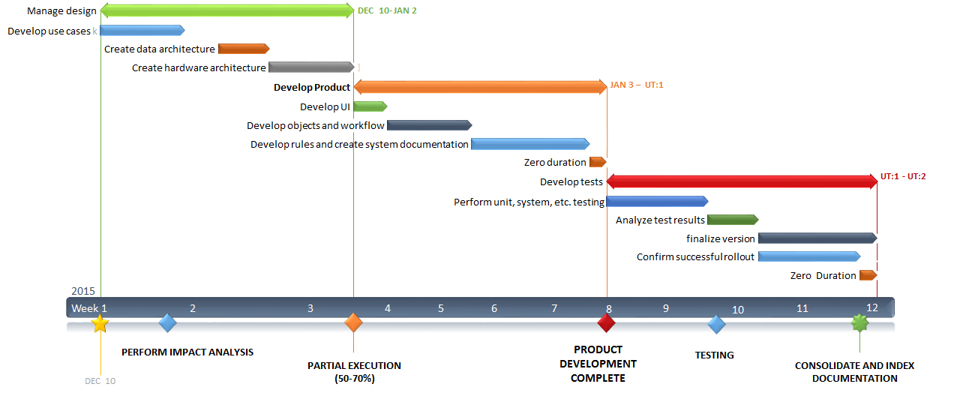

Figure 6.1 Timeline Chart (VIII Semester)

22
8. CONCLUSION

ATTLD security system can be installed in mobile easily. This security system is suitable for a real time monitoring of the object and avoid the theft. The application included a transmitting module which contains an embedded system to combine Bluetooth devices to retrieve location of objects and it to the ATTLD users. ATTLD is made to make low cost and excellent anti-theft control system. ATTLD users will anonymously and securely help you to ﬁnd lost/stolen objects. This essentially expands your reach to anywhere in the world. The more number of people use it the better the capability!

23
REFERENCE

[1] Jake M. Laguador, Moulle M. Chung, Frina Joy D. Dagon, Julie Ann M. Guevarra, Rommel J. Pureza, Jeffrey D. Sanchez, and Dan Kenneth I. Sta. Iglesia, Anti Car Theft System using Android Phone, International Journal Of Multidisciplinary Sciences And Engineering, Vol. 4, No. 5, June 2013.

[2] Nateq Be-Nazir Ibn Minar, and Mohammed Tarique ,Bluetooth Security Threats And Solutions: A Survey, International Journal of Distributed and Parallel Systems (IJDPS) Vol.3, No.1, January 2012.

[3] Dr. Saleem Ahmad, Ruoyu Lu, Muhammad Ziaullah, Bluetooth an Optimal Solution for Personal Asset Tracking: A Comparison of Bluetooth, RFID and Miscellaneous Anti-lost Tracking Technologies, International Journal of u- and e- Service, Science and Technology 03/2015; Vol:8(No.3):179-188. DOI: 10.14257/ijunesst.2015.8.3.17

[4] I. A. Mingkhwan, Wi-Fi Tracker: An Organization Wi-Fi Tracking System, In Proceedings Canadian Conference On Electrical And Computer Engineering Ccece ’06.

[5] Wilson M. Yeung, Joseph K. Ng, Wireless LAN Positioning based on Received Signal Strength from Mobile device and Access Points, in Proceedings of 13th IEEE International Conference on Embedded and Real-Time Computing Systems and Application, RTCSA07.

[6] Ted Tsung-Te Lai, Chun-Yi Lin, Ya-Yunn Su, and Hao-Hua Chu BikeTrack: Tracking Stolen Bikes through Everyday Mobile Phones and Participatory Sensing www.csie.ntu.edu.tw/˜yysu/BikeTrack phonesense11.pdfo

[7] Guha, S., Plarre, K., Lissner, D., and Bhagavathy Krishna, S. M., Dutta, P., and Kumar, S. Autowitness: Locating and tracking stolen property while tolerating gps and radio outages, In SenSys, 2010

[8] . Dawson, Device Tracking on a Scattered Bluetooth-Enabled Network, BscDissertation, Faculty of Engineering, University of Bristol, May 2005

[9] A, Frunzke T and Dressler F, 2007, Adaptive Distance Estimation and Localization in WSN using RSSI Measures. In: Proceedings of the 10th Euromicro Conference on Digital System Design Architectures, Methods and Tools, 471-478
24

[10] Rohitaksha K , Madhu C G , Nalini B G ,Nirupama C V .Android Application for Vehicle Theft Prevention and Tracking System, Rohitaksha K et al, / (IJCSIT) International Journal of Computer Science and Information Technologies, Vol. 5 (3) , 2014, 3754-3758

25

